For running the c the mingW is already installed

🡪Go to vs code type the code to run press right key on mouse and then run code and the code will run there OR On the right side of the vs code there is the run button click on it to run

🡪For the c and c++ the ming w compiler is installed

🡪And there is an problem while writing the code that in the main if we write directly printf in the if than it would not be printed, And to overcome this problem, We have to write some thing in the printf before any condition

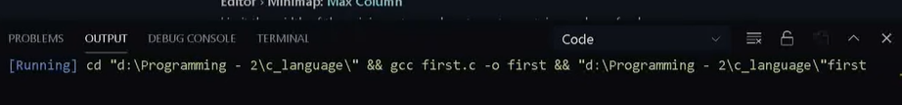

🡪If the c code in the vs code is made to run but the process on the output screen is showing the **running** all the time and the program is not running than follow the following step:

1. Go to the settings in the vs code
2. Type **code runner run in terminal** in the search bar and if the tick is off than make it on

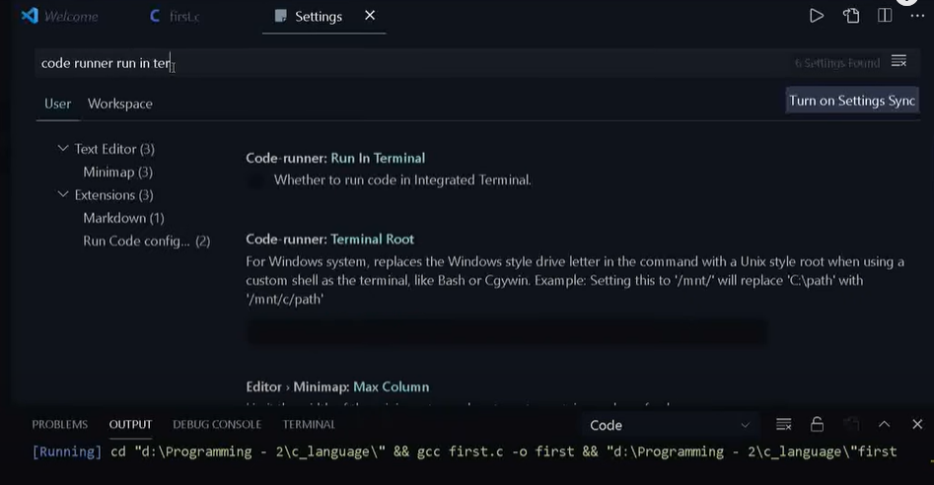

**TO**

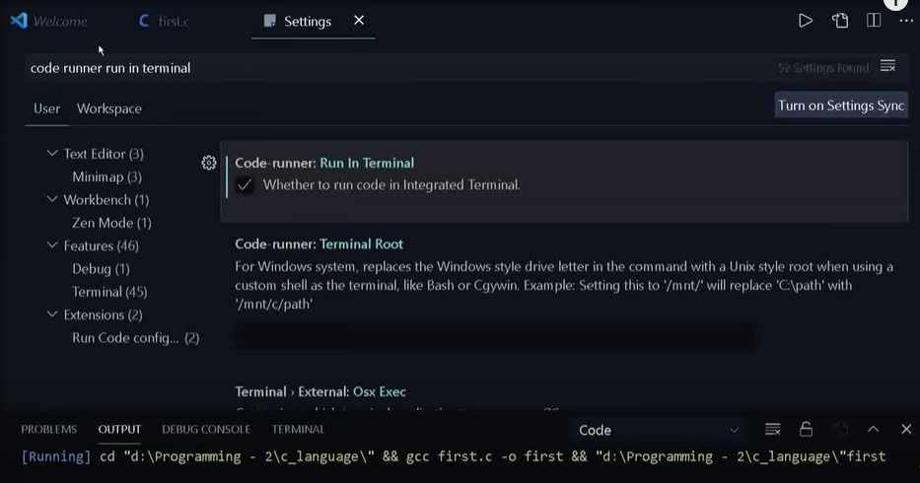

1. And than restart the vs code, and try to run the program and than the program will run automatically(TADA problem solved)